TutorTube: Dot Products and Matrix Multiplication Spring 2021
Introduction
Hello and welcome to TutorTube, where The Learning Center’s Lead Tutors help you understand challenging course concepts with easy to understand videos. My name is Ryan Nyhus, Lead Tutor for Mathematics. In today’s video, we will explore Dot Products and Matrix Multiplication. Let’s get started!

Dot Products
Before we are able to multiply matrices, we need to understand dot products. A dot product is a combination of multiplication and addition between two vectors. Given two vectors
A = [ $\begin{matrix}a & b & c\end{matrix}$ ] and D = [ $\begin{matrix}d & e & f\end{matrix}$ ],
the dot product A $∙$ D is defined by
A $∙$ D = ad + be + cf.
That is, the dot product is the summation of the products of the ith element of each vector. Note that for a dot product to be defined, both vectors must have the same number of elements.

Dot Product Example 1
Let’s do a quick example. What is the dot product of A and B if A = [1 3 4] and B = [4 5 2]? Recall that for a dot product, we take the ith element of each vector and multiply them together, then sum the products.
So A $∙$ B = 1(4) + 3(5) + 4(2) = 4 + 15 + 8 = 27.

Dot Product Example 2
Let’s do another quick example. What is the dot product of A and B if A = [2 5 3 4] and B = [3 2 6 4]?
A $∙$ B = 2(3) + 5(2) + 3(6) + 4(4) = 6 + 10 +18 + 16 = 50.

Matrix Layout
Before we are able to multiply matrices, we also need to understand the matrix layout. Each element of the matrix can be recognized by two numbers, one corresponding to the row it is in, the other corresponding to the column it is in. The letter i is typically used to describe the row position, and the letter j is typically used to describe the column position. We write each element as a_{ij}. We say a matrix is of size m x n, where m is the number of rows in a matrix, and n is the number of columns in a matrix. I find a diagram is easier to understand, so by this description, a matrix looks like the following:
Figure 1 [Matrix (Mathematics)]:
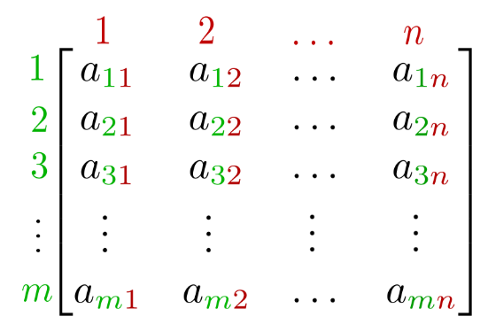
This image shows the layout of a matrix as described above. The subscript i increases down the rows of the matrix, while the subscript j increases across the columns of the matrix, both from 1 to n.

Notice that each element is described by its row and column in the subscript a_{ij}. A smaller example, a 3 x 3 matrix, looks like the following:
Figure 2 (Nave, R):
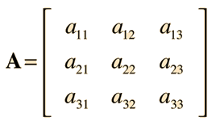.
This image shows a 3x3 matrix, with elements in the a_{ij} notation

Now that we understand the layout of a matrix, we can discuss how to multiply matrices.

Multiplying Matrices
Let’s take two matrices, A and B, and multiply them together to get a third matrix C. Before multiplying two matrices, you must check that their dimensions are compatible. For two matrices to be compatible, the matrix on the left, A must have the same number of columns as the number of rows of the matrix on the right, B.
Each element of this new matrix C, c_{ij} is formed by the dot products of row i of matrix A and column j of matrix B.

Example: Matrix Multiplication
[ $\begin{matrix}1 & 3 \\ 4 & 5 \\ 6 & 8\end{matrix}$ ] * [$\begin{matrix}3 & 5 & 7 \\ 2 & 3 & 8\end{matrix}$].
The dimensions for the resultant matrix C should be 3x3, which is the number of rows of matrix A by the number of columns of matrix B.
Let’s find c_{11.} That is, let’s find the element of the first column and row of matrix C. By the dot product method, we take the dot product of the first row of matrix A, [1 3], and first column of matrix B, [3 2]. The dot product [1 3] • [3 2] = 1(3) + 2(3) = 9.
Let’s put this into our matrix C:
[$\begin{matrix}9 & c12 & c13 \\ c21 & c22 & c23 \\ c31 & c32 & c33\end{matrix}$].
Now let’s do the rest of the dot products.
c₁₂ = [$\begin{matrix}1 & 3\end{matrix}$] • [$\begin{matrix}5 & 3\end{matrix}$] = 1(5) + 3(3) = 14
c₁₃ = [$\begin{matrix}1 & 3\end{matrix}$] • [$\begin{matrix}7 & 8\end{matrix}$] = 1(7) + 3(8) = 31
c₂₁ = [$\begin{matrix}4 & 5\end{matrix}$] • [$\begin{matrix}3 & 2\end{matrix}$] = 4(3) + 5(2) = 22
c₂₂ = [$\begin{matrix}4 & 5\end{matrix}$] • [$\begin{matrix}5 & 3\end{matrix}$] = 4(5) +5(3) = 35
c₂₃ = [$\begin{matrix}4 & 5\end{matrix}$] • [$\begin{matrix}7 & 8\end{matrix}$] = 4(7) + 5(8) = 68
c₃₁ = [$\begin{matrix}6 & 8\end{matrix}$] • [$\begin{matrix}3 & 2\end{matrix}$] = 6(3) + 8(2) = 34
c₃₂ = [$\begin{matrix}6 & 8\end{matrix}$] • [$\begin{matrix}5 & 3\end{matrix}$] = 6(5) + 8(3) = 54
c₃₃ = [$\begin{matrix}6 & 8\end{matrix}$] • [$\begin{matrix}7 & 8\end{matrix}$] = 6(7) + 8(8) = 106.
Now fill these in to their respective entries:
[$\begin{matrix}9 & 14 & 31 \\ 22 & 35 & 68 \\ 34 & 54 & 106\end{matrix}$].
This is matrix C. You can follow this procedure for any size matrix, as long as their dimensions are compatible.

Outro
Thank you for watching TutorTube! I hope you enjoyed this video. Please subscribe to our channel for more exciting videos. Check out the links in the description below for more information about The Learning Center and follow us on social media. See you next time!

References
Gilbert Strang. 18.06SC Linear Algebra. Fall 2011. Massachusetts Institute of Technology: MIT OpenCourseWare, https://ocw.mit.edu. License: Creative Commons BY-NC-SA.
“Matrix (Mathematics).” Wikipedia, Wikimedia Foundation, 31 Jan. 2021, en.wikipedia.org/wiki/Matrix_(mathematics).
Nave, R. (n.d.). Matrices. Retrieved February 08, 2021, from http://hyperphysics.phy-astr.gsu.edu/hbase/Math/matrix.html

